WEEK: 6
Train a sentiment analysis model on IMDB dataset, use RNN layers with LSTM

Sentiment analysis is a Natural Language Processing (NLP) technique used to identify whether a text expresses a positive or negative opinion.

In this program, an RNN (Recurrent Neural Network) with LSTM (Long Short-Term Memory) layers is trained on the IMDB movie review dataset to classify movie reviews as positive or negative. The model learns patterns and relationships between words in the reviews. LSTM layers help remember important information from previous words and understand the context of a sentence.

AIM: To write a python program to train a sentiment analysis model on IMDB dataset, use RNN layers with LSTM.

Algorithm:
- Start the program.
- Import the necessary libraries and dataset.
- Build the model by using RNN Model.
- Compile and train the model.
- Predict the model by using user input.
- Stop the program.

Program:
import numpy as np
import tensorflow as tf
from tensorflow.keras.datasets import imdb
from tensorflow.keras.preprocessing import sequence
from tensorflow.keras.models import Sequential
from tensorflow.keras.layers import Embedding, LSTM, Dense
from tensorflow.keras.preprocessing.text import Tokenizer

# Load the IMDB dataset
max_features = 10000
maxlen = 200
batch_size = 32

(x_train, y_train), (x_test, y_test) = imdb.load_data(num_words=max_features)

# Pad sequences to ensure uniform input size
x_train = sequence.pad_sequences(x_train, maxlen=maxlen)
x_test = sequence.pad_sequences(x_test, maxlen=maxlen)

# Build the model
model = Sequential()
model.add(Embedding(input_dim=max_features, output_dim=128, input_length=maxlen)) # Embedding layer
model.add(LSTM(128, dropout=0.2, recurrent_dropout=0.2)) # LSTM layer
model.add(Dense(1, activation='sigmoid')) # Output layer

# Compile the model
model.compile(loss='binary_crossentropy',
optimizer='adam',
metrics=['accuracy'])

# Train the model
model.fit(x_train, y_train,
batch_size=batch_size,
epochs=5,
validation_data=(x_test, y_test))

# Evaluate the model
score, acc = model.evaluate(x_test, y_test, batch_size=batch_size)
print('Test score:', score)
print('Test accuracy:', acc)

# Function to decode IMDB word index back to English
word_index = imdb.get_word_index()
index_to_word = {index: word for word, index in word_index.items()}

def decode_review(encoded_review):
return ' '.join([index_to_word.get(i - 3, '?') for i in encoded_review])
# Sample text prediction
def predict_sentiment(text):
# Preprocess the input text
tokenizer = Tokenizer(num_words=max_features)
tokenizer.fit_on_texts([text])
sequences = tokenizer.texts_to_sequences([text])
padded_seq = sequence.pad_sequences(sequences, maxlen=maxlen)
# Make a prediction
prediction = model.predict(padded_seq)
sentiment = "Positive" if prediction >= 0.5 else "Negative"
print(f"Prediction: {prediction[0][0]:.4f} - Sentiment: {sentiment}")

Output:

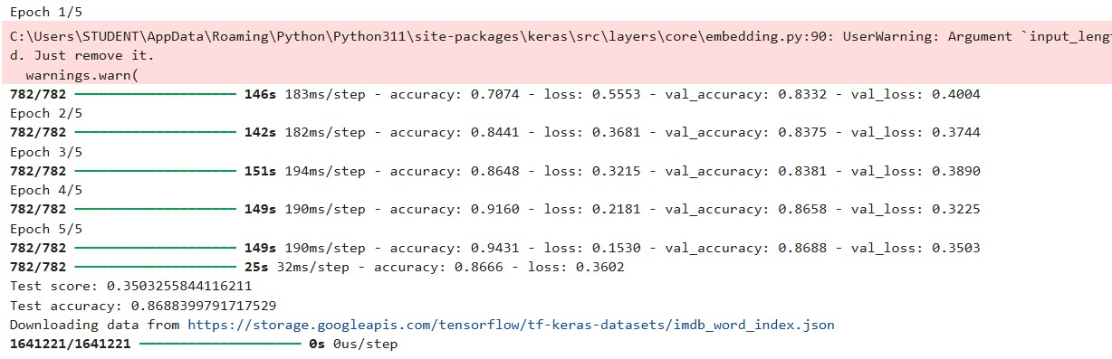

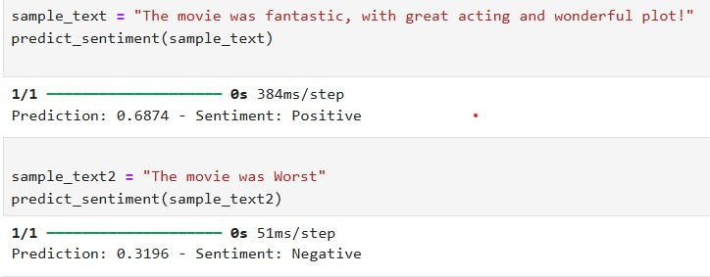

Result:
Thus, the sentimental analysis models on IMDB dataset are applied in the field NLP and the model was evaluated and predicted the results successfully.

